MA4605 Laboratory F week 7

Using ANOVA for testing the goodness-of-fit of regression

The following results were obtained when each of a series of standard silver solutions was analysed by flame-absorption spectrometry.

|  |  |  |  |  |  |  |  |
| --- | --- | --- | --- | --- | --- | --- | --- |
| Concentration(X) | 0 | 5 | 10 | 15 | 20 | 25 | 30 |
| Absorbance(Y) | 0.003 | 0.127 | 0.251 | 0.390 | 0.498 | 0.625 | 0.763 |

|  |
| --- |
| Conc=c( 0, 5, 10, 15, 20, 25, 30)  Abso=c( 0.003, 0.127, 0.251, 0.390, 0.498, 0.625, 0.763) |

Determine the slope and the intercept of the calibration plot and their confidence limits.

We determine the slope and intercept of the calibration plot using the linear regression model function **lm().**

|  |
| --- |
| FitA = lm(Abso~Conc)  summary(FitA)  confint(FitA) |

**Using ANOVA to test the goodness-of-fit of the linear relationship.**

We can also test for significance the slope of the simple linear model by means of ANOVA. The null hypothesis for the analysis of variance is H0 : β1 = 0 and the alternative hypothesis is H1 : β1 ≠ 0

The ANOVA table for regression line is obtained by calculating the variation due to regression (SSR) and the variation around the regression line(SSE).

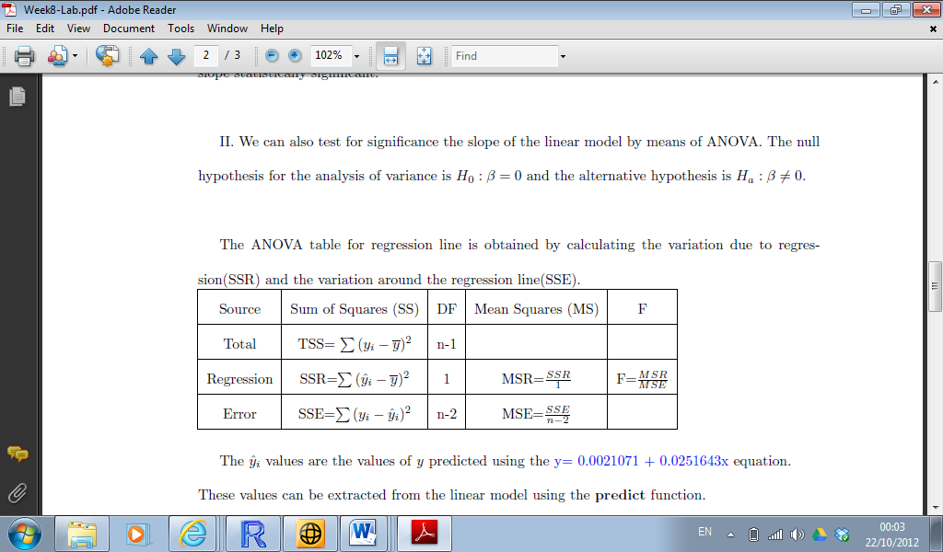

The fitted $\hat{y}$ values are the values of y predicted using the regression equation.

These values can be extracted from the linear model using the predict function.

The residuals can also be extracted from the model with the residuals function.

|  |
| --- |
| preds = predict(FitA)  resids = resid(FitA) |

The total sum of squares TSS

|  |
| --- |
| Abso  length(Abso)  mean(Abso)  Abso-mean(Abso)  (Abso-mean(Abso))^2  TSS = sum((Abso-mean(Abso))^2)  TSS |

The sum of squares due to regression SSR

|  |
| --- |
| preds  (preds-mean(Abso))^2  SSR = sum((preds-mean(Abso))^2)  SSR |

The sum of squares around regression SSE

|  |
| --- |
| SSE = sum((resid)^2)  SSE |

The mean sum of squares are :

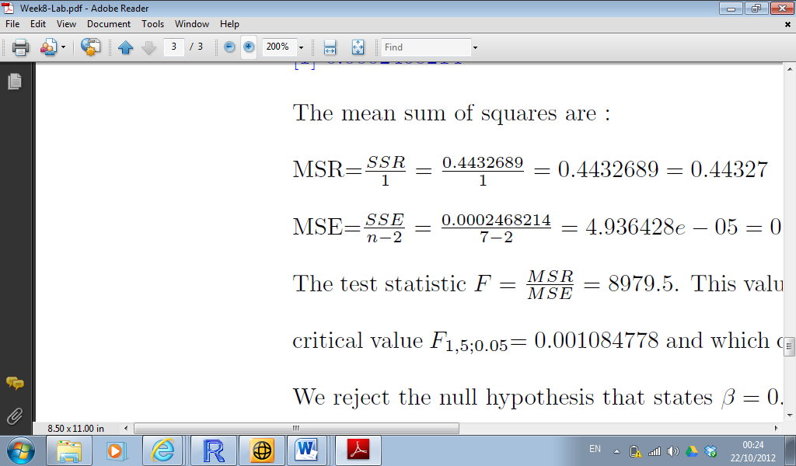

Where the sample size is ‘n’.

We can compute the Mean Square Values and the Test Statistic.

|  |
| --- |
| MSE = SSE/(length(Abso)-2)  MSR = SSR/1  MSE  MSR  Fts = MSR/MSE  Fts |

The test statistic F = MSR

MSE = 8979:5. This value is very significant since it is much greater than the

critical value F1;5;0:05= 0.001084778 and which can be obtained in R with qf(0.975,1,5,lower.tail=F).

We reject the null hypothesis that states _ = 0.

The ANOVA table can be obtained for the regression model with the command: > anova(model)

Analysis of Variance Table

Response: y

Df Sum Sq Mean Sq F value Pr(>F)

x 1 0.44327 0.44327 8979.5 2.481e-09

Residuals 5 0.00025 0.00005

The same conclusion can be drawn from the t-test for the slope:

Coefficients:

Estimate Std. Error t value Pr(> jtj)

(Intercept) 0.0021071 0.0047874 0.44 0.678

x 0.0251643 0.0002656 94.76 2.48e-09

The p-value = 2.48e-09 is less than 0.05 hence we reject the null hypothesis _ = 0.

3